**Course: Advance Bio Informatics**

**Module Title: Phylogenetic Tree Building Methods**

**Module No: 58**

There are several methods available which can be found in text books and internet resources. But here we will focus only on four methods. In this module, I will provide some introduction of the following four methods. Details of these will be provided in subsequent modules.

1. Distance based
2. Maximum Parsimony
3. Maximum likelihood
4. Bayesian Inference

**Distance Based Methods:** These methods analyze pair wise alignments of the sequences. Distance information is used to infer relatedness between all taxa. One common example is UPGMA which stands for un-weighted pair group methods with arithmetic mean.

**Maximum parsimony:** Character based method in which columns of residues are analyzed in a multiple sequence alignment to identify the tree with the shortest overall branch lengths that can account for the observed character differences.

**ML and Bayesian Inference:** Model based statistical approaches in which the best tree is inferred that can account for the observed data.

**Maximum Parsimony**

|  |  |  |  |
| --- | --- | --- | --- |
|  | **1** | **2** | **3** |
| **A** | G | G | G |
| **B** | G | T | G |
| **C** | T | G | T |
| **D** | T | T | T |

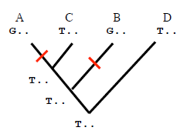

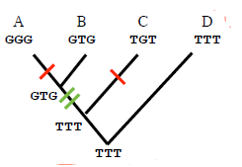

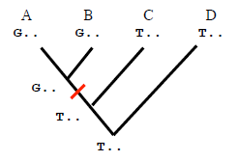

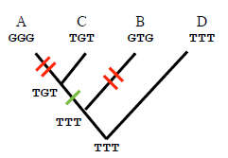

**Algorithm**

Construct list of all possible trees for data set

For each tree: determine length, add to list of lengths

When finished: select shortest tree from list

If several trees have the same length, then they are equally good (equally parsimonious)